|  |  |  |
| --- | --- | --- |
| ENSE 885aw, (Researching) People-Centred Design  Final Exam, Spring 2020  Tuesday, June 23, 2020  8:00 am – 5:00 pm (strict 5:00 pm URCourses submission deadline)  Location: URCourses/Remote | Dr Tim Maciag | Full Name:  DHAVAL BHAILALBHAI PATEL | |
| Student #:  200439819 | |
| Activity | Student score | Maximum score |
| Part 1 |  | 30 |
| Part 2 |  | 10 |
| Total |  | 40 |

**IMPORTANT NOTE**: You will put your responses in this file (starting below under “student responses” on Page 3). Ensure to save and upload this file as a PDF. By uploading and submitting this file in URCourses you acknowledge that your submission was individually completed, and words, discussions, responses provided are your own. The instructor reserves the right to set-up a zoom meeting with individual students to provide clarification and/or to ensure comprehension of selected topics and provided responses before submitting final grades.

**Part 1: Select six (6) of the following topics** and discuss it from the perspective of your team’s project (how does the topic apply to your team’s design/development (project submission), or how could it apply given envisioned future work?). Providing screenshots and/or new low-fidelity prototypes of future envisioning demonstrating specific linkages to selected topics is absolutely essential. When responding, think about what your team explored, what your team proposed, what your team did, how your team envisions future evolution of design/development to be, how the concept applies to your/your team’s project design and development (features and functionality), limitations, successes, user interactions (designed, developed, envisioned), user activities (designed, developed, envisioned), etc. Each topic is worth five (5) marks. Your response will be marked on the quality (understanding and comprehension of the topic), not quantity (number of words, length), of your discussion and how well you link your team’s designed project ideas to selected topics.

* Heuristic evaluation
* Gulf of interaction (execution and evaluation)
* Metaphors and mappings
* Affordances/signifiers
* Inclusive design
* Complexity and simplicity in design
* Constraints (physical, cultural, semantic, logical)
* Understandability and discoverability
* False-consensus effect
* End-end experiences, features, and functionality

**Part 2: Select two (2) topics from a research paper not your own** and discuss it from the perspective of your team’s project, similar to what you did in Part 1 (what you designed and/or describe a new idea (experience + lo-fi prototype) for a future design). Higher marks will be given for discussing linkages to course topics. Ensure you specifically state which of the student research papers you selected for each topic. Each topic is worth five (5) marks. Your response will be marked on the quality (understanding and comprehension of the topic), not quantity (number of words, length), of your discussion and how well you link your team’s designed project ideas to selected topics.

Student research paper titles

Links to papers available in URCourses (Final exam section)

Matthew Amos

* L.Palen. “Social, Individual, & Technological Issues for Groupware Calendar Systems”, 1999
* K.Cheverst, N.Davies, K.Mitchell, A.Friday, C.Efstratiou. “Developing a Context-aware Electronic Tourist Guide: Some Issues and Experiences”, 2000

Tanvi Dave

* W.Cockayne, M.Zyda, P.Barham, J.Falby. “The laboratory for human interaction in the virtual environment”, 1996
* S.Oviatt. “Interfaces for thinkers: computer input capabilities that support inferential reasoning”, 2013

Reema Jiyani

* M.Goldstein, R.Book, G.Alsio, S.Tessa. “Non-Keyboard QWERTY Touch Typing: A Portable Input Interface for The Mobile User”, 1999
* J.Guerreiro, A.Rodrigues, K.Montague, “T.Guerreiro, H.Nicolau, D.Goncalves. “TabLETS Get Physical: Non-Visual Text Entry on Tablet Devices”, 2015

Rupinder Kaur

* A.G.Hauptmann, M.J.Witbrock, M.G.Christel. “Artificial Intelligence Techniques in the interface to a Digital Video Library", 1997
* J.S.G.Leon, A.G.Gonzalez, D.S.Rios, A.S.Sanchez. “PACo: An Educative Instrument to Transform Society”, 2017

Aoun E Muhammad

* B.J.Fogg, H.Tseng. “The Elements of Computer Credibility”, 1999
* D.Wang, Q.Yang, A.Abdul, B.Y.Lim. “Designing Theory-Driven User-Centric Explainable AI”, 2019

Dhaval Patel

* S.W.Mereu, R.Kazman. “Audio enhanced 3D interfaces for visually impaired users”, 1996
* M.S.Baldwin, J.Mankoff, B.Nardi, G.Hayes. “An Activity Centered Approach to Nonvisual Computer Interaction”, 2020

Milin Patel

* S.Wilson, M.Bekker, P.Johnson. “Helping and Hindering User Involvement — A Tale of Everyday Design”, 1997
* W.W.Gaver, J.Beaver, S.Benford. “Ambiguity as a Resource for Design”, 2003

Tonmoy Sarker

* C.Greenhalgh, S.Benford. “MASSIVE: A Collaborative Virtual Environment for Teleconferencing”, 1995
* M.D.Dunlop, R.McCartan, M.Roper, B.McGregor, M.Elliot. “Using smartphones in cities to crowdsource dangerous road sections and give effective in-car warnings”, 2016

Nidhi Saseendran

* A.Sears, B.Shneiderman. “Split menus: effectively using selection frequency to organize menus”, 1994
* B.Lim Y.Rogers, N.Sebire. “Designing to Distract: Can Interactive Technologies Reduce Visitor Anxiety in a Children’s Hospital Setting?”, 2019

Rezvan Shokrani

* G.Singh, M. Green. “Designing the interface designer's interface”, 1988
* G.Nedelcheva, E.Shoikova. “Coupling Design Thinking, User Experience Design and Agile: Towards Cooperation Framework”, 2017

Bipin Suram

* A.C. Long. “Improving Gestures and Interaction Techniques for Pen-Based User Interfaces”, 1998
* L.Morales, S.M.Artega, S.Kurniawan. “Design Guidelines of a Tool to Help Blind Authors Independently Format Their Word Documents”, 2013

**Student responses:**

…select your class and research paper topics from above and write about them here. Ensure to mention which topic you are writing about and/or what student paper and associated topics you are writing about for each selected

**PART 1**

**[1] Gulf of interaction (execution and evaluation)**

The gulfs of interaction (execution and evaluation) are like canyons that divide the user and the world they interact with. My objective while designing the new website for RCE Saskatchewan was to narrow this gulf for better user experience.

For example, based on the class discussions and our research we found out that current RCE website login functionality does not have a password field in the sign-up form. Merging the functionality of signup and login under one login functionality and displaying text formatting in the signup form can be avoided as these can create confusion for some user thus widening the gulfs of interactions.

My proposed solution to design the login functionality was to make it simpler avoiding all the technical jargon like text formatting and make it simple for users to interact with. So by filling out a simple form and by clicking on the signup button, the users will know what task they are executing and what will be the system state(here a pop up of successful sign up) to expect when the task is successfully completed.

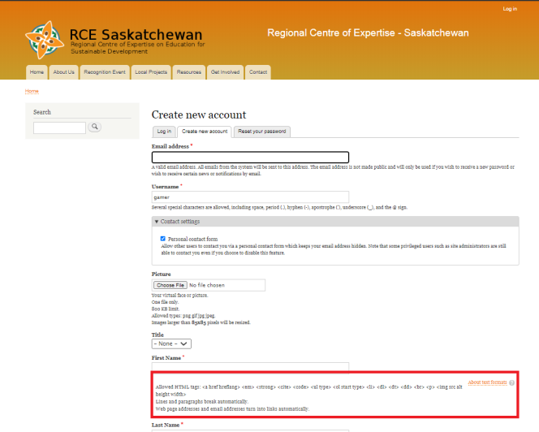 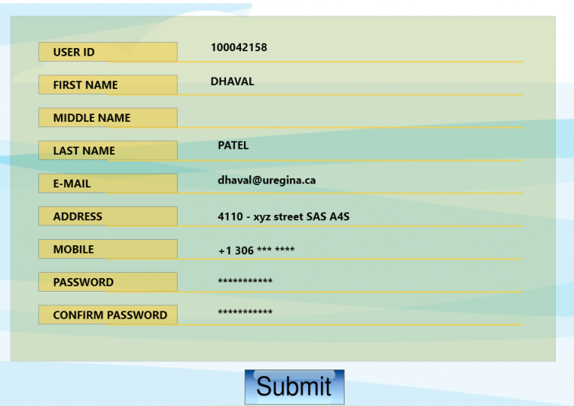

current design my design

My understanding of this class topic allowed me to explore the psychology behind how users are going to interact with my designs thus bridging the gulf of execution and what they will be expecting as an end result and what will be my system state after the task is performed thus provide me with the opportunity to narrow the gulf of evaluation. We tried to introduce a proper data flow in our new designs which were missing on the current website. The limitations that I found while bridging this gulf through our design is that our design was less refined and our vision for the future is to refine them in a manner that improves user experience.

**[2] Metaphors and mapping**

Metaphors according to me are pointers that act as a signpost which help users to perform their desired task. I think that metaphors should be clear what they represent in a way that helps users to understand the flow of the website. A fuzzy metaphor can lead to a design disaster. The best way I believe to implement a metaphor is to have a good understanding of the design situation. I tried to use the metaphors based on knowledge in the world thus they make the same sense to a variety of different users. The mapping of good metaphors to the functionality that they point to increases the user's delight and usability. So in a nutshell, according to me, metaphors are a minimalist way of describing a design idea to users.

We tried to incorporate metaphors in our design wherever it was possible as they aid in keeping our design simple and avoid chaos when a user interacts with our system. For example, when designing the event page functionality where users can view and participate event.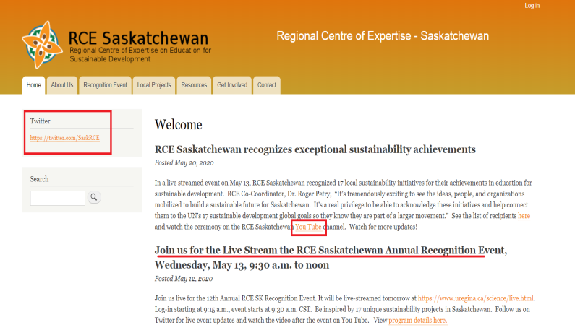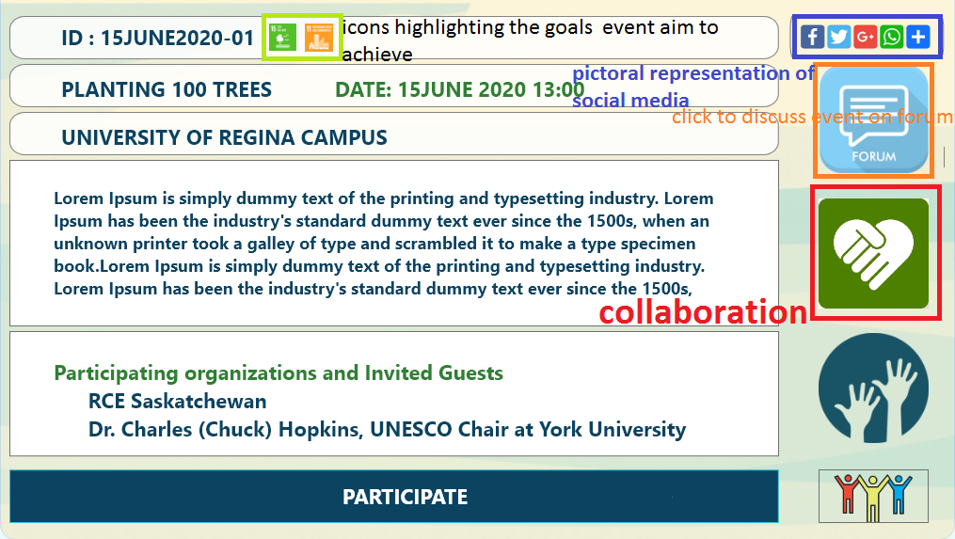

current design my design

The current design does not have clear metaphors. But in my proposed design (event section) I have places Button/icon(affordance) that guide the user in performing the desired task(signifier)(here discussing the event with others) and not to read the entire content (to learn how to follow RCE event) thus introducing metaphors in the design helped me to organize the content of the website and keep the designing approach novel. We have used gestalt theory for mapping the content that is similar in a single unit. for example in the dashboard functionality of users button for the profile, subscribed event and donation are grouped together as they refer to the same user. The future vision for my design with regards to metaphors is that I will try to introduce more metaphors where ever possible and avoiding fuzzy metaphors in my design.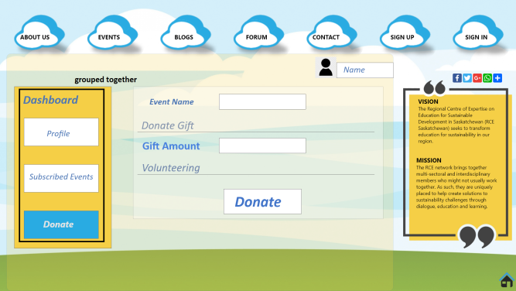

**[3] Inclusive Design**

The definition of the inclusive design is to design in a way in which our design consideration includes extreme users or users with specific needs. I tried to design my website based on providing accessibility for blind users. I also considered that all of the functionalities provided in my design will not be used by these special users. So, I limited my work to only provide accessibility for core functionality that these users might use like home page, view events, log in.

For example,

After presenting my research presentation I realized how difficult it was for the blind or limited-sighted user to excess the current RCE website. As the current site is littered with content it is difficult to excess it with screen reader technology(A tech that read content on-screen) which is one of the popular technology to aid blind people. Also the size of the "login in" is so small it might be difficult for limited sighted users to read it comfortably.

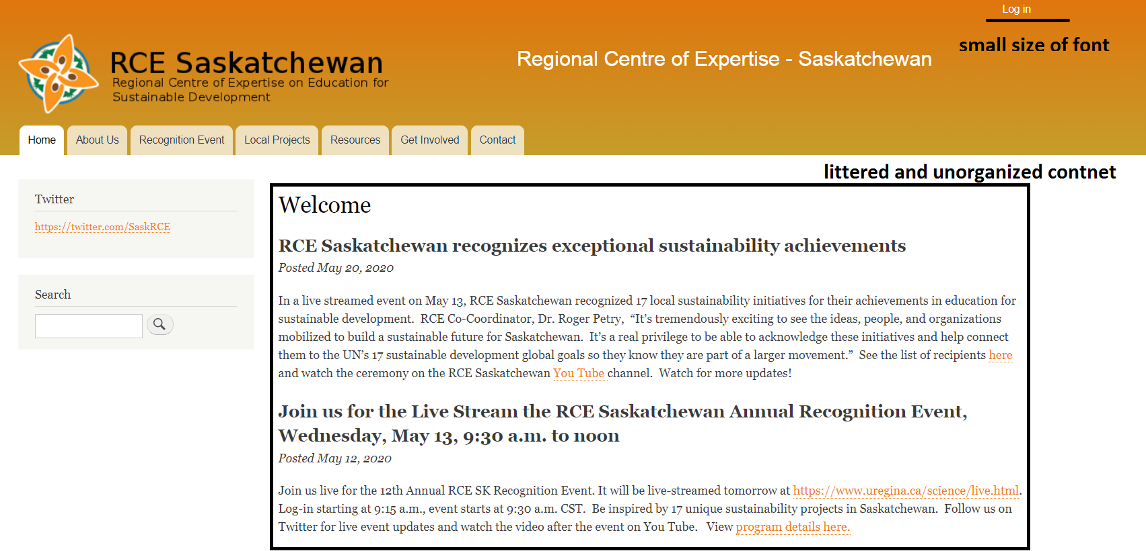

In my proposed design of the event page, I have organized the content and optimized it for screen-reader technology. So all the content is not displayed at once. In designing the security feature in login page I decided to use CAPTCHA's(completely automated public Turing test to tell computers and humans apart) instead of OTP(one-time password) or other popular means as they provide a way to fill them out based on audio feedback for blind users.

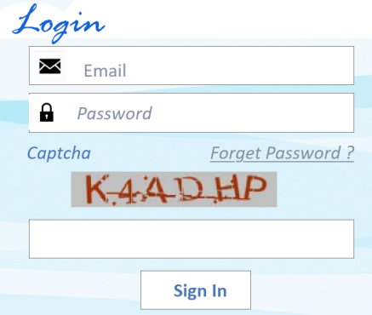 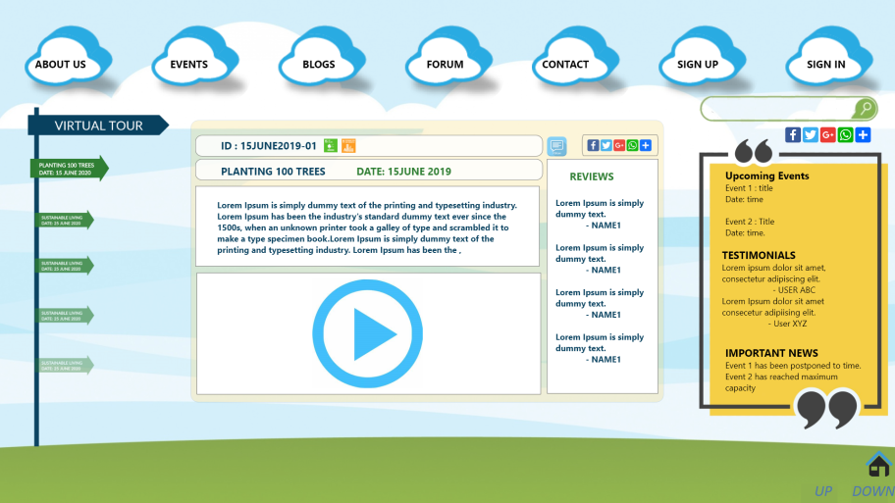

Moreover, expanding the idea of the inclusive design we mainly focused on the north star customers which includes the general public and designed functionalities which they might want to see in the newly designed RCE website and taking an inclusive design approach for what we believe were the key functionalities of the website. Our future goal is to include more interesting features that can be design modified for inclusive design.

**[4]False -** **consensus effect**

False-Conesus effect helped me to put myself in my stakeholders' shoes and made me design functionalities based on the requirement of the actual user and not considering "I am the user". In the first phase of the fast feedback cycle or the divergence phase of the diamond model. We interacted with the RCE stakeholders that helped us to figure out different kinds of users of the RCE website that we were designing. In the problem definition we focused on the general public as our prime user or the north star user as we believed that for an NGO like RCE to be recognized and flourish, it is paramount for them to receive support from the general public.

Instead of directly diving into the designing phase we used a novel approach and used various techniques like Empathy mapping and User story to figure out their core requirements of our users. We found out that certain functionalities like blogging and donation were important for our stakeholders. Those requirements also align with our idea of designing this functionality for the general public as it would help them know RCE up close and contribute to RCE through the website. Inspired by the concept of fresh snow we thought about other features(like about us, forum, an events page, etc) that our north star customer would like to have on the website. So, Rather than following the waterfall model and develop a website for all the "users under the sun" we focused more on northstar users.

The empathetic approach along with the false- consensus effect has help me to design the website based on the actual subconscious need of the users.

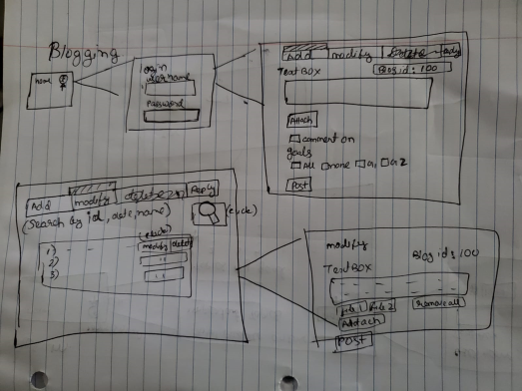  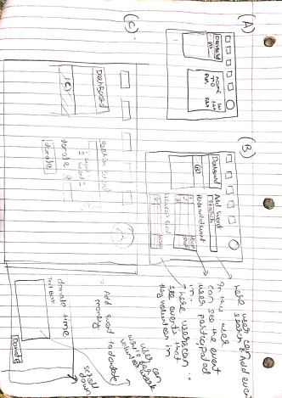

**[5]Understandability and Discoverability**

The concept of Understandability and Discoverability helped us to frame our design diagrams. We want the RCE website to be minimalist or simple. We wanted to design it in a way user cannot miss out on any features the website pages have to offer upon visiting them and making them discoverable. The colour and design scheme were inspired by the Saskatchewan flag with inspire users to relate to RCE Sk. The main menu was fairly simple stating all the pages available to explore. We tried to organize the content and functionality in a way it is expected to be arranged on a website worldwide. For example, we put a virtual tour under the About us section which describes RCE endeavours. Moreover, our main menu was embedded in every page to improve navigation and flow.

To improve understandability on our website we introduced metaphors that guide users what they might expect if they click on the buttons. For example, clicking on the play button in the virtual tour section user can expect a video is going to be played and by clicking the navigation arrows user can move through the image video gallery for that event.(discussed metaphors in question 2).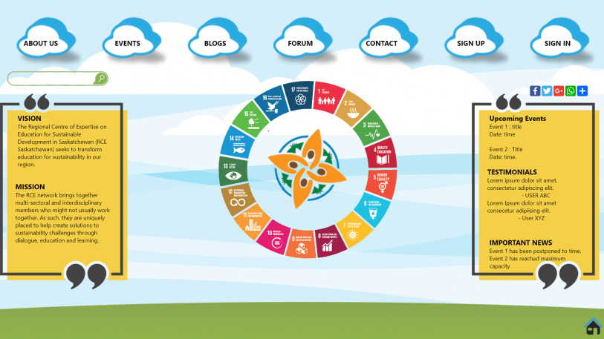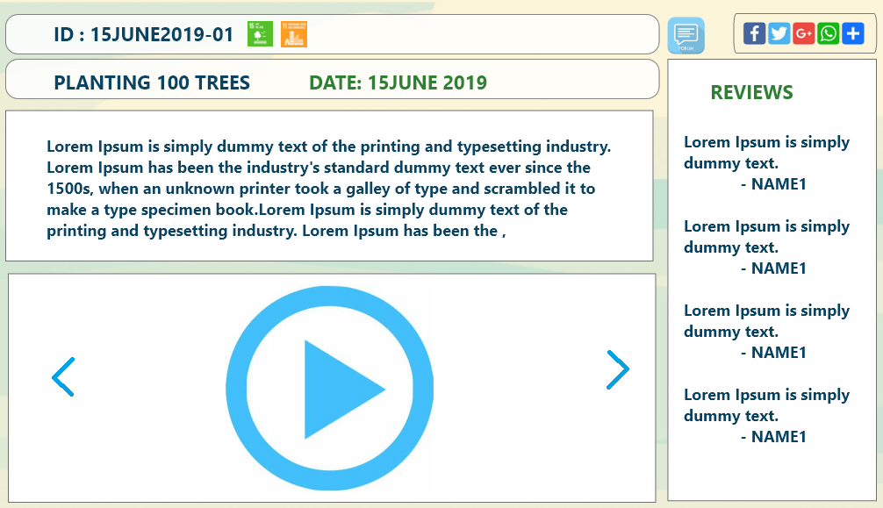

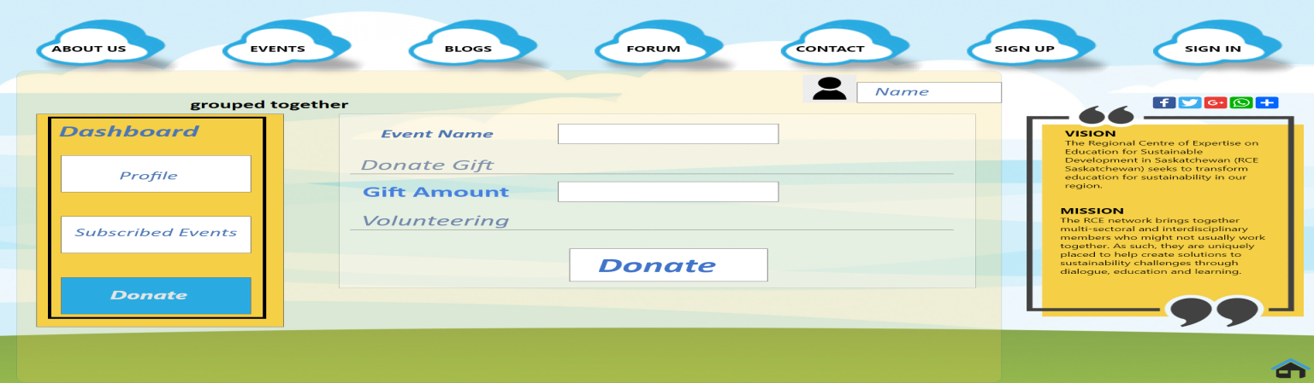

To improve discoverability, we have mapped the content that are similar in a single unit. for example in the dashboard functionality of users button for profile, subscribed event and donation are grouped as they refer to the function user can perform from the dashboard when logged in.

To improve understandability and discoverability in future for our current design we would like the idea of providing pop-up's notifications when the profile information is updated and other feedbacks. We like to improve how our button are placed in some of the pages to improve grouping.

**[6]CONSTRAINTS**

According to me constraints can be both bane and boon for a designer based on how he thinks he can incorporate them in the design. A well incorporated constraint can improve usability of design but it can be disastrous. We have designed our website based on knowledge in the world. By keeping website design simple and focused on end to end experience we believe we have manage to overcome few constraints. For example,

* The simple main menu provide all the functionality that website offers thus limiting the way user can interpret it.
* constraint on logging in to comment in forum has improve site security and user can be responsible for his/her comment.
* the dashboard page which can only be viewed after signing helps to provide personalization.
* When gathering data from users in our design, we had constraints in form of norms so it was important to clearly mentions the privacy policy for the users.

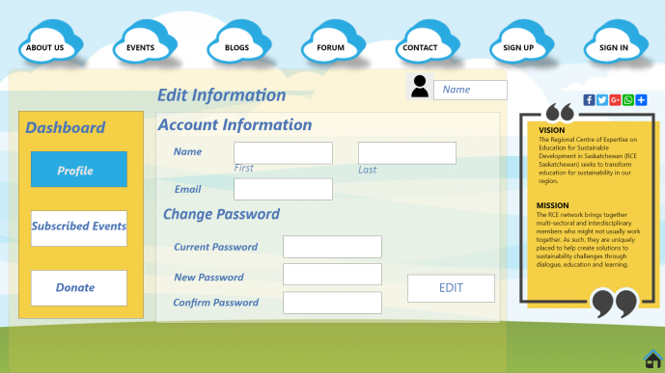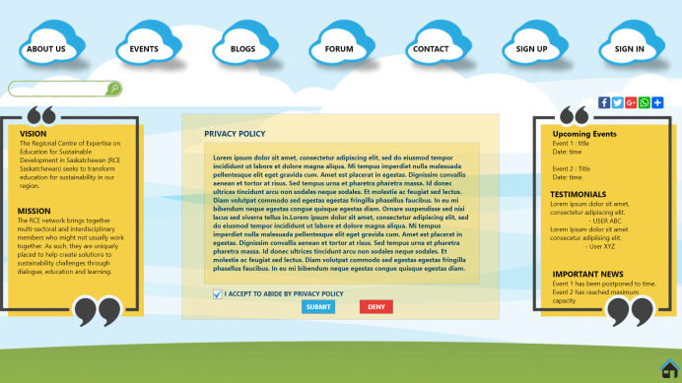

* We have faced cultural constraints when deciding the color schema for our website due to political situations of Saskatchewan.
* We have tried to implement the logical constraint in dashboard functionality where user is displayed information based on the button he clicks on the dashboard.

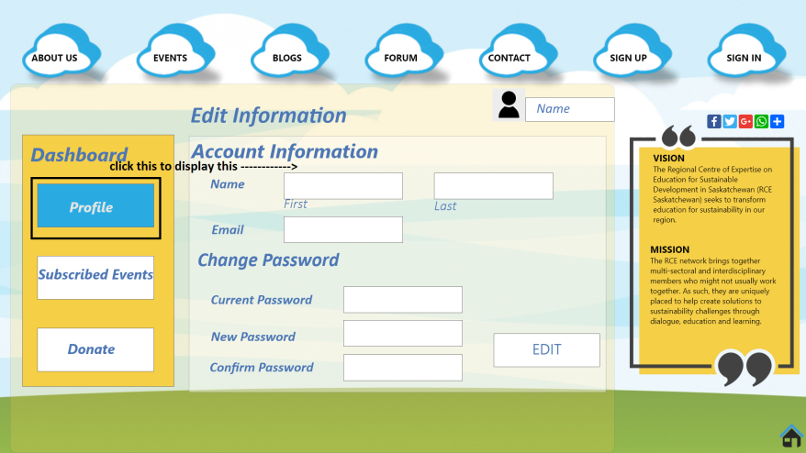

Thus using forcing functions and constraint we tried to design our website in a way that improves user experience.

**PART 2**

**[1] W.W.Gaver, J.Beaver, S.Benford. “Ambiguity as a Resource for Design”, 2003**

The reason behind me choosing this paper is that it present a novel idea of incorporating ambiguity into the design. When designing the website for RCE which a NGO one does not think about presenting ambiguity in the design. But after reading this paper I have went through the design mock-ups that we have created and tried to find out ambiguity in design. I would like to point out few and propose new ideas

* The color scheme of the website was chosen keeping Saskatchewan in mind but to some political supporters might think differently.
* we can add content on the virtual tour arouse ambiguity. For example, the scenario before RCE initiative and scenario after RCE initiative can be displayed in the virtual tour section under about us that can help people appreciate the endeavours of RCE.

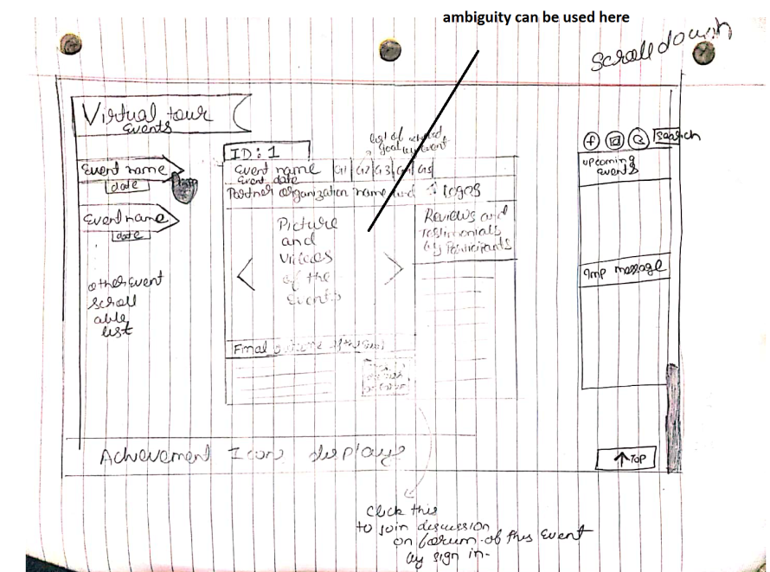

* The icons used in the design are not of the same family this can be interpreted as diversity of contributors that are contributing for RCE Saskatchewan.

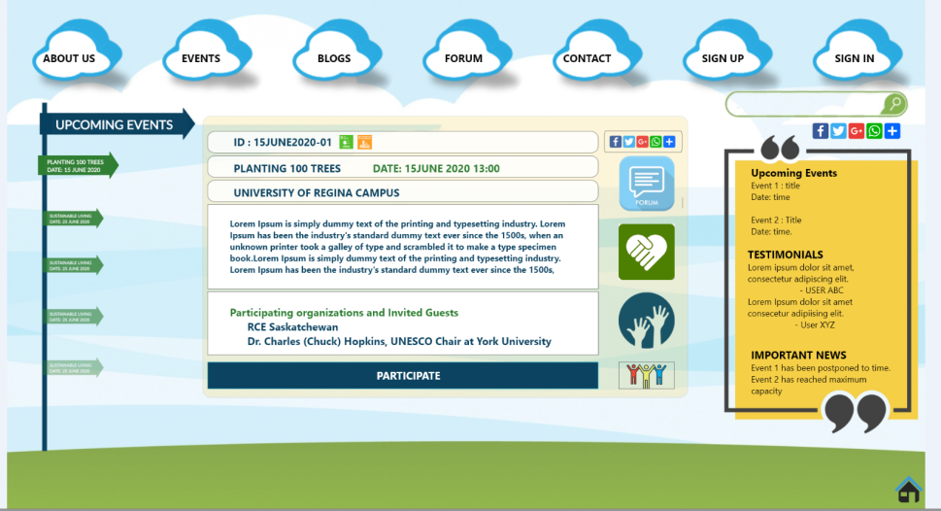

* Finally the entire design seems to be ambiguous as it seems to be designed for the kids. Yet we can interpret it as call from mother nature for her children to follow path of sustainable development before it's too late which is the Mission of RCE Sk.

**[2]** **G.Nedelcheva, E.Shoikova. “Coupling Design Thinking, User Experience Design and Agile: Towards Cooperation Framework”, 2017**

The reason for me to choose this paper is that we have used the similar concept and development model demonstrated in this paper to develop our website. we have followed the Agile development model which is based on the concept of fast feedback cycle of observe, frame, brainstorm, build.

During the divergence phase of designing which includes observe and brainstorming. we mainly focus on quantities of ideas rather than quality of the ideas. We did that using user story mapping which helped us to dive deep into need of our users and provide solution for their requirement and frame new functionalities. Moreover, empathy mapping helped us to understand the deepest subconscious need of our customers. We also gave thoughts about what can be a hindrance in developing website for RCE in form of various constraints.

During the convergence phase we designed prototypes that can help us to explain our ideas to RCE stakeholders. Prototypes were based more on end to end user experience rather than scrutinizing minute details this intern has helped our customer to understand our design better. Based on the feedback received we can improve the design in the next iterative agile cycle.

This was all done in a team collaboration thus we achieved our goal through agile model of development in a cooperate like environment. Thus we tried to incorporate the actual needs of the users in the agile development process along with providing customer satisfaction and user delight. moreover, the concept discussed in this paper was used in a real world problem scenario.